LA-IMPERIAL



**Group Members:**

* **M.Areeb Siddique** Student1397595
* **Shayan Ahmed Siddique** Student1399708
* **Aashir Aamir Baig** Student1398617
* **Group (A)**

**Faculty :**

* **Faculty Name :** Amir Hamza
* **Coordinator Name :** Iqra Khan
* **Batch Code :** 2207G3
* **Center Name :** Aptech NN

**INTRODUCTION**

The thirst for learning, upgrading technical skills and applying the concepts in real

life environment at a fast pace is what the industry demands from IT professionals

today. However busy work schedules, far-flung locations, unavailability of convenient

time-slots pose as major barriers when it comes to applying the concepts into

realism. And hence the need to look out for alternative means of implementation in

the form of laddered approach.

The above truly pose as constraints especially for our students too! With their busy

schedules, it is indeed difficult for our students to keep up with the genuine and

constant need for integrated application which can be seen live especially so in the

field of IT education where technology can change on the spur of a moment. Well,

technology does come to our rescue at such times!!

Keeping the above in mind and in tune with our constant endeavour to use

Technology in our training model, we at Aptech have thought of revolutionizing the

way our students learn and implement the concepts using tools themselves by

providing a live and synchronous eProject learning environment!

**So what is this eProject?**

eProject is a step-by-step learning environment that closely simulates the classroom

and Lab based learning environment into actual implementation. It is a project

implementation at your fingertips!! An electronic, live juncture on the machine that

allows you to

* Practice step by step i.e. laddered approach.
* Build a larger more robust application.
* Usage of certain utilities in applications designed by user.
* Single program to unified code leading to a complete application.
* Learn implementation of concepts in a phased manner.
* Enhance skills and add value.
* Work on real life projects.
* Give a real life scenario and help to create applications more complicated and
* useful.
* Mentoring through email support.

The students at the centre are expected to complete this eProject and send complete

project along with the documentation to eProjects Team

Looking forward to a positive response from your end!!

**PROBLEM STATEMENT**

La Imperial is into selling Appliances. Company has been selling these products for

last 20 years. They have a wide range of Appliances. The company advertises by

distributing the pamphlets, advertising on television and so on. Due to rapid

development in internet field, the company decides to launch a website where people

will get all the information about the various products available with them easily.

**Requirement Specification:**

The Web site is to be created based on the following requirements.

1. Home Page should contain logo of the site with proper sections and details of Appliances with suitable images.
2. The site should display a menu which will contain the options for brief introduction about the various appliances available, location of the shop and any other information if required.
3. The information should be categorized according to the brand names of the products like if a User wants to see only “HAIER” products or any other companies products then he/she can click on a Link/button/menu etc and can see only that Brand products.
4. Another category option for different appliances, like ‘Washers &amp; Dryers’ etc should be created and accordingly the products should be listed.
5. When a user selects any particular brand, a list of products for that brand will be displayed.
6. A brief summary of features of individual products should be displayed on the Web Page along with the product but detailed Features should be stored inIndividual Word documents which can be downloaded or viewed by the User who wishes to see the same.
7. The user should also be able to compare the various products of different as well as similar brands.
8. There should be a “Contact Us” page which will have the Address of the Company which is as follows and the mail address which when clicked willinvoke the local mail client from where they can send an email.

**PROBLEM STATEMENT SOLVED**

We made a logo that we used in the navbar and the new made cards for the products

We used dropdown to showcase the brands. For each brand we made product’s categories

Then we made product pages for individual products where user gets to know about the individual product and he can add it to cart or if user want to learn more about the product he can download t he information . Then we made a page where user can compare the products . Then we made a contact us page where user can track our outlet our working hours and some contact info .

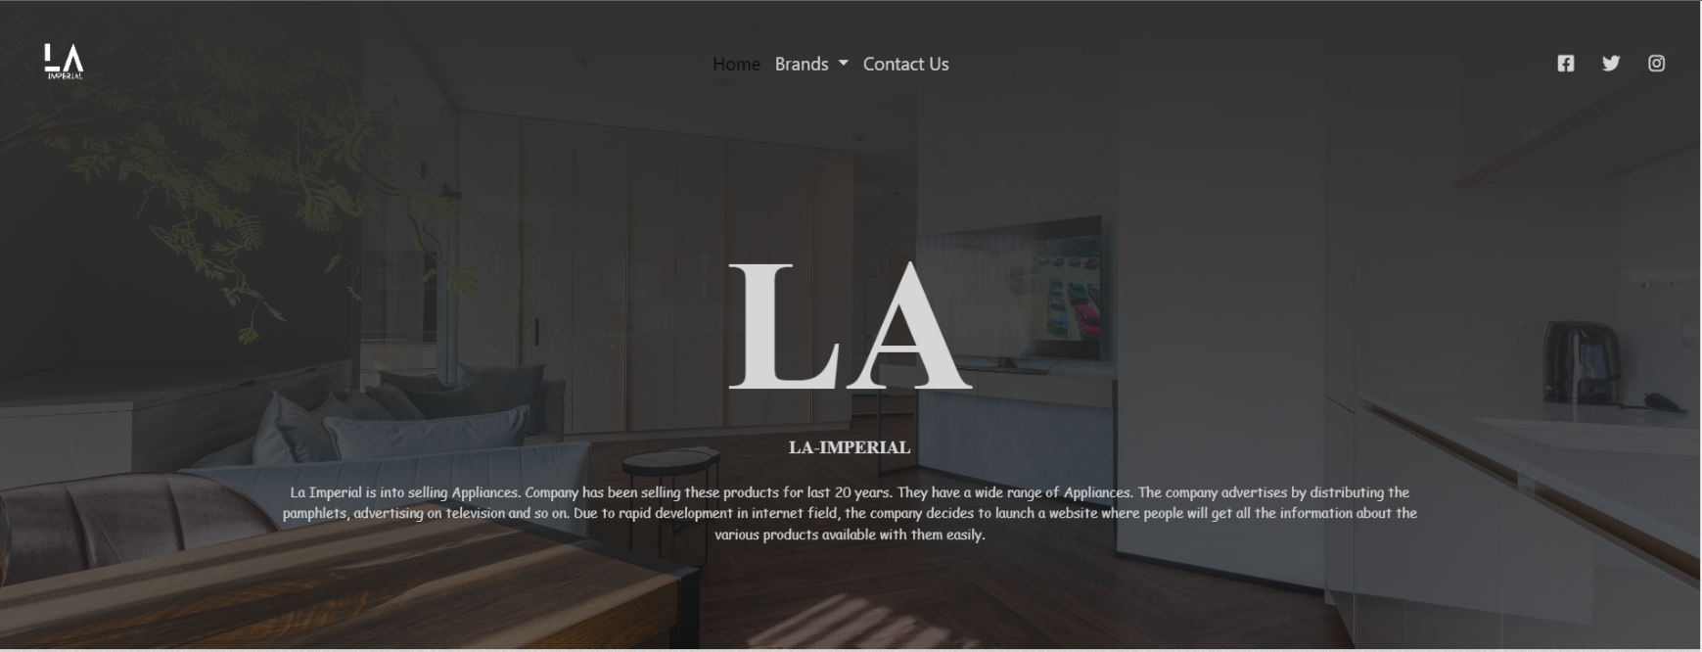

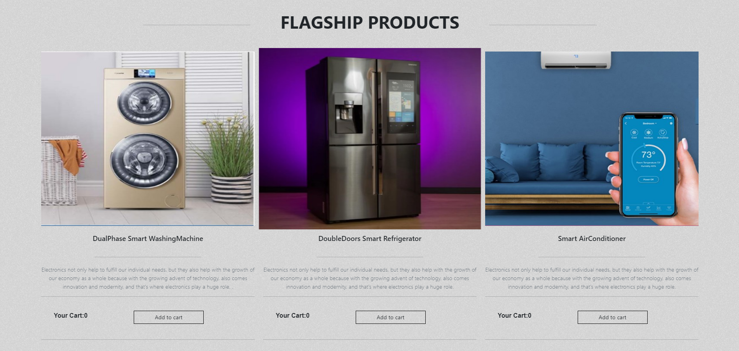



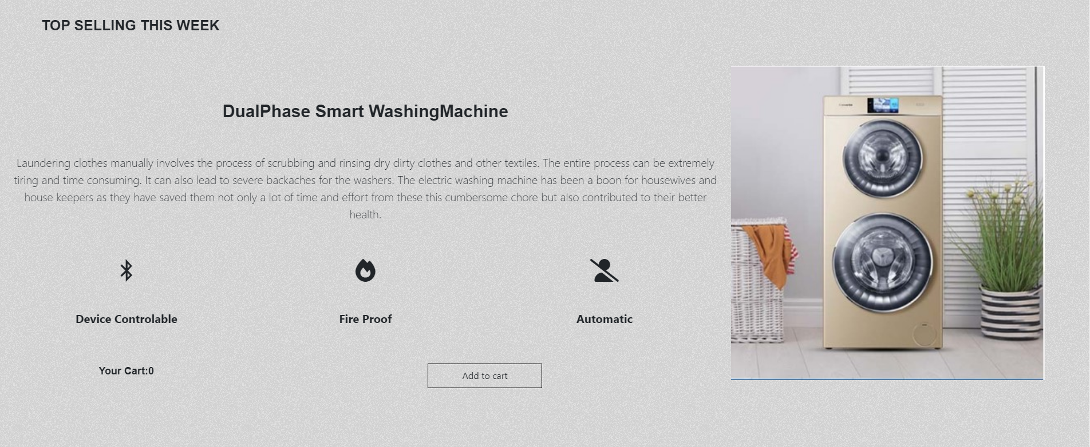

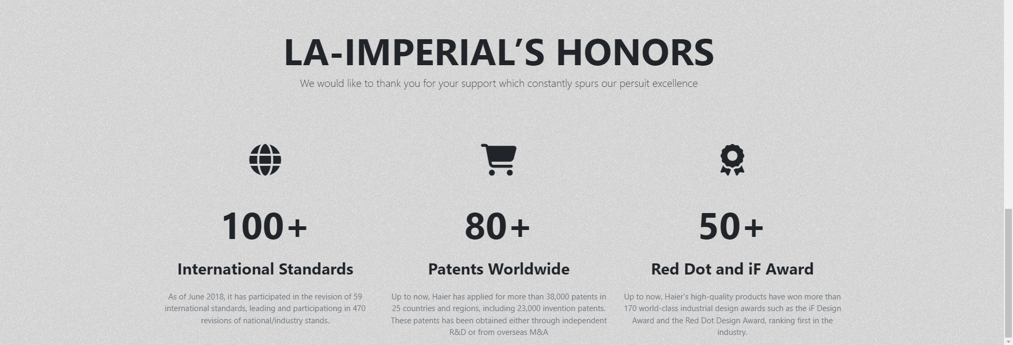

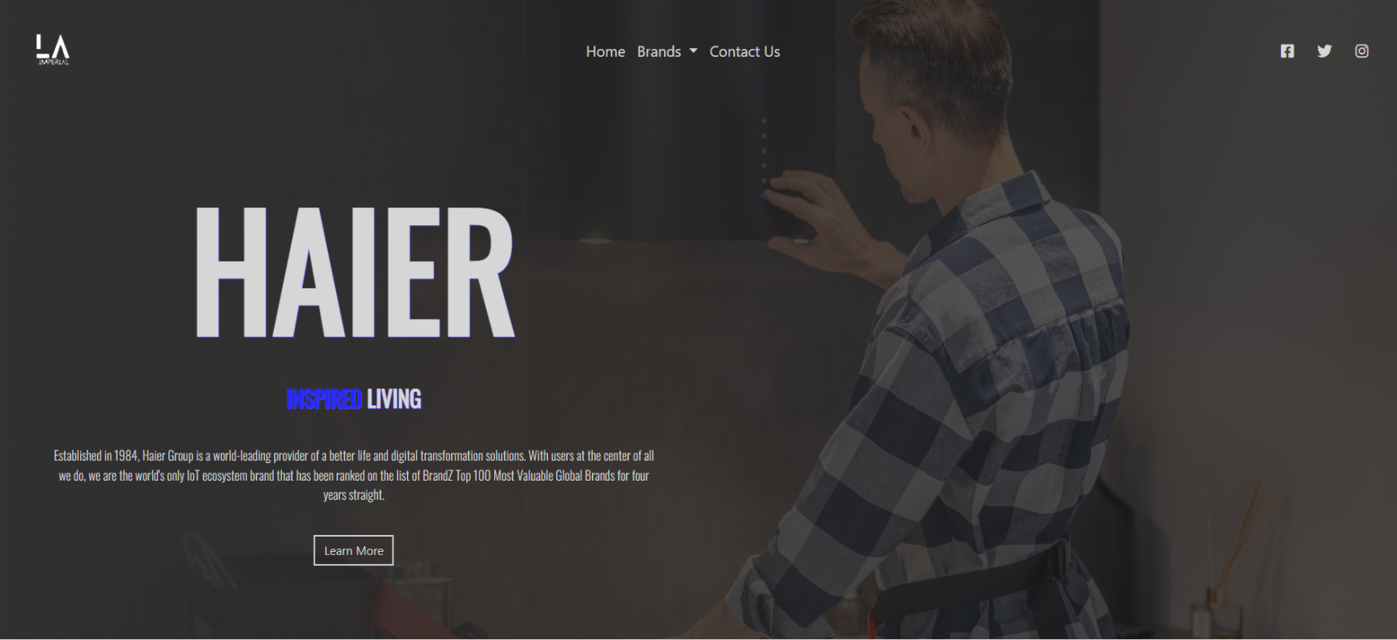

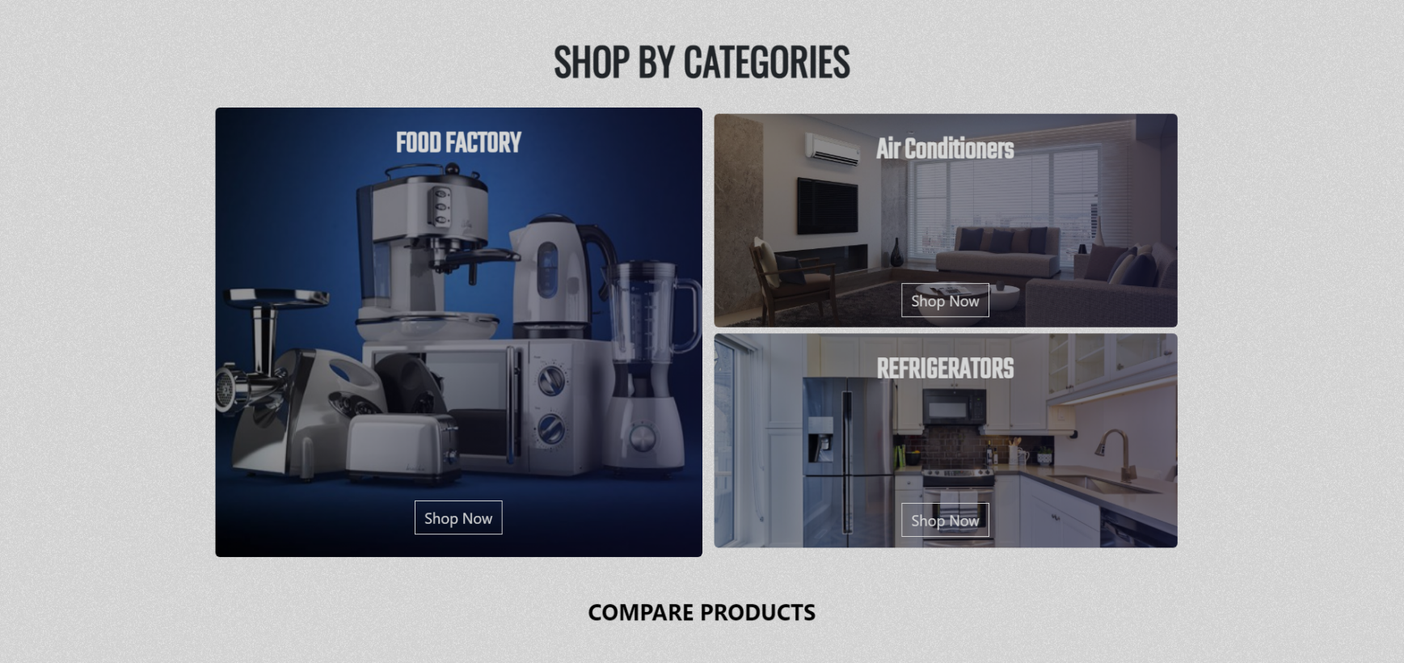

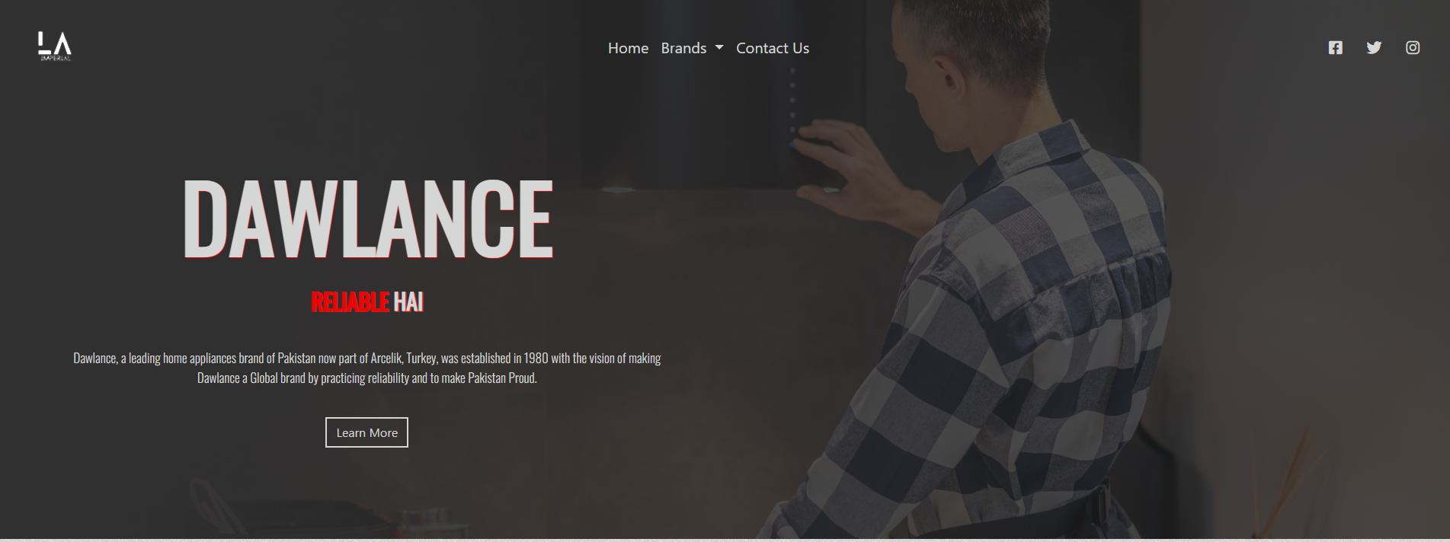

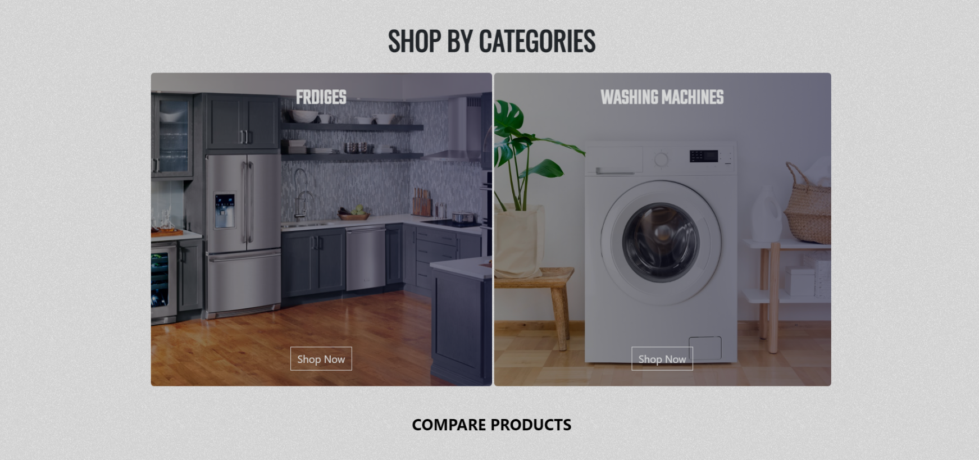

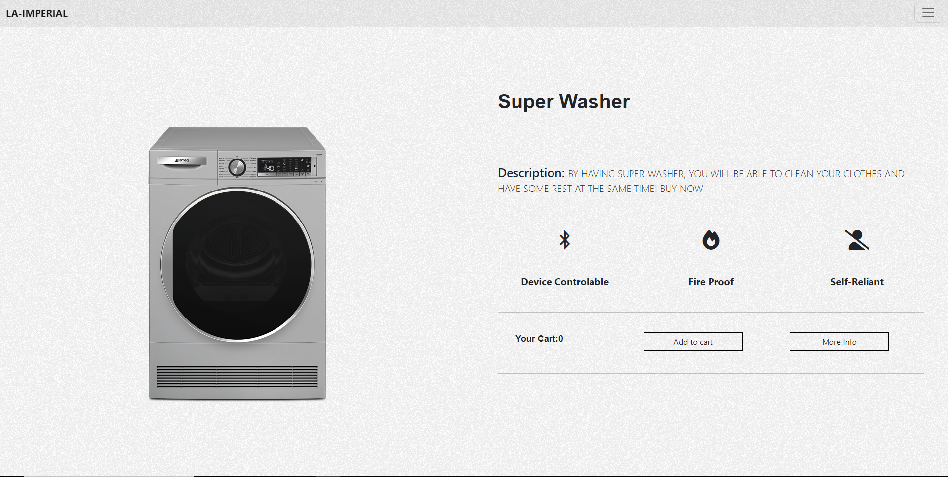

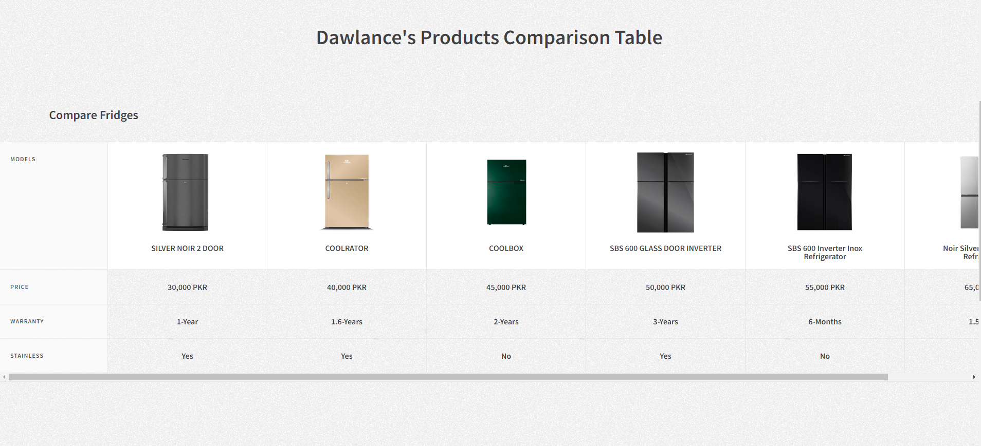

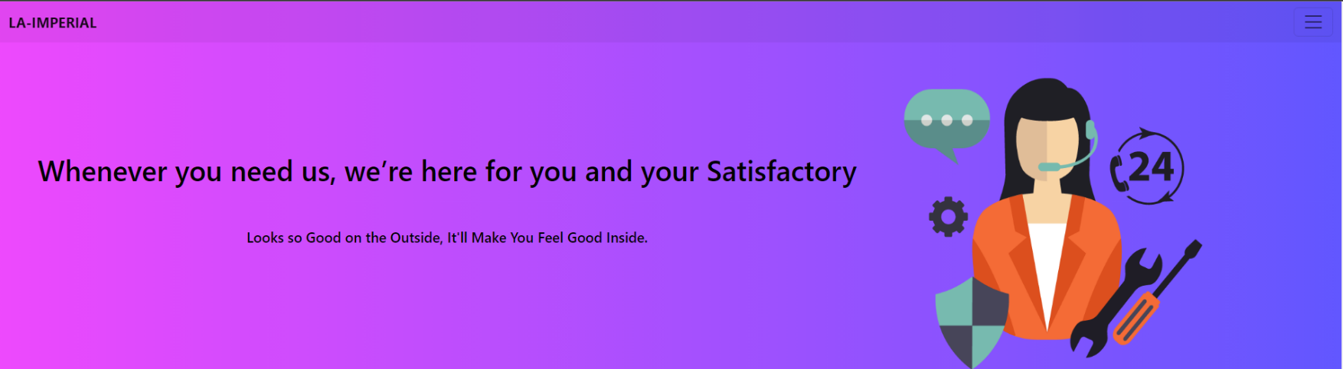

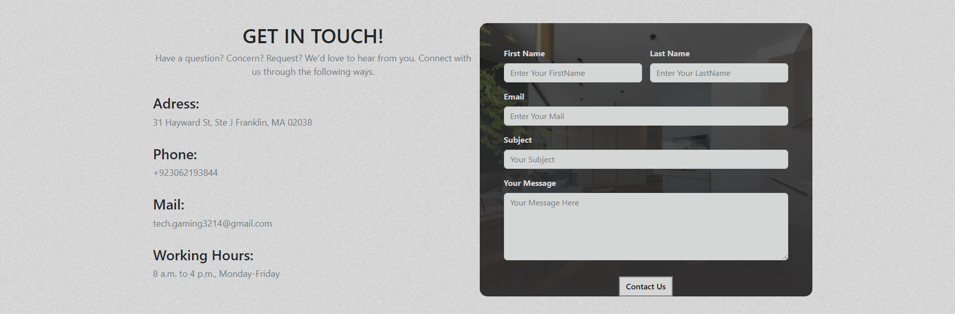

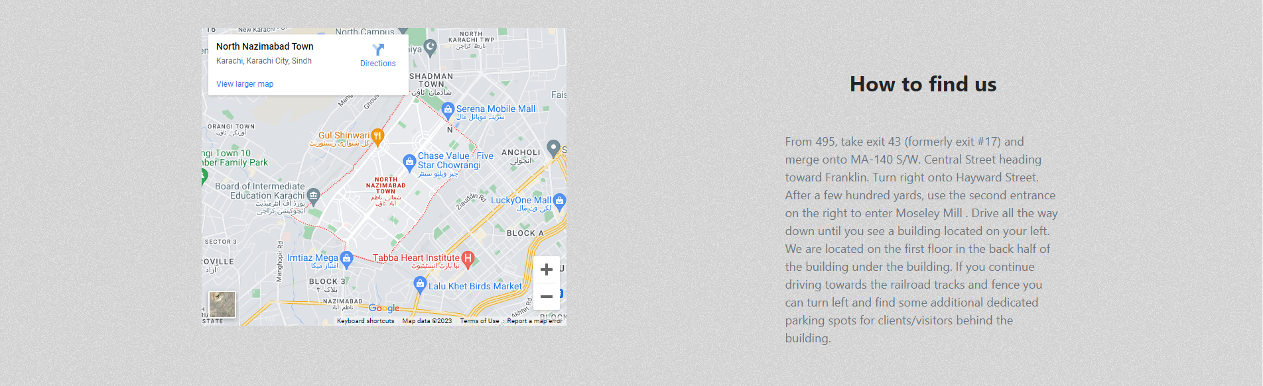

**HARDWARE/SOFTWARE REQUIREMENTS**

HARDWARE

* A minimum computer system that will help you access all the tools in the courses is a Pentium 166 or better
* 64 Megabytes of RAM or better

SOFTWARE

* Notepad/HTML editor
* Dreamweaver
* IE 5.0/ Netscape 6.0